

E-Project

**Web Designing**

**Provide Insurance for Cars and other Vehicles**

|  |  |
| --- | --- |
| **Author** | 1**. TRIEU LE MINH** student1165165 *(Leader)*  2. **THOM VU THI** student1233668  3. **TRUC DANG VU THUY** student1233663  4. **VAN NGUYEN THI THANH** student1219202 |
| **Centre Name** | Aprotrain Aptech |
| **Date** | Start Date: 27-May-2020  End Date: 26-Jun-2020 |
| **Semester** | 1 |
| **Instruction** | **TRI PHAN HUU** |

**HCM City 26th June 2020**

**PREFACE**

Today, the more developed the world, the greater the human need. Because the world is in the process of industrialization and modernization, travel has become more convenient thanks to traveling by means of transportation.

People or vehicles all need ***insurance***, so the V triple T team built a store to provide ***insurance*** ***packages*** to consumers. However, this store is not the same as before because the modernity and the presence of the Internet have helped V triple T group create an online store that people call it a website.

***Insurance*** is like a loss-sharing, which helps us save a lot of money when the vehicles have an accident or some unexpected damage occurs. Not all insurers suffer these damages but only one of them, so this indirect sum is the financial sharing between people and people, so ***insurance*** participation is required.

The website that the V triple T group wants to introduce to everyone is from **Safe Carz Limited**, which will provide ***insurance*** for users from many different companies. The website supports online buying and selling to help users save time, quickly and effectively, and the company always has many incentives for customers when using products with us.

We always prioritize customer benefits above all so that all customers who come to our company always feel satisfied and trusted when using. In addition to this, we also expect to receive cooperation from customers in fulfilling their obligations when purchasing ***insurance*** packages from **Safe Carz Limited.**

In addition, the V trip T group would like to express its sincere thanks to the teachers and siblings in the “**Aptech** international programmer training system”, Especially Mr. TRI PHAN HUU .

**Requirement Specification**

* Home Page should contain logo of the site with proper sections and details of the various Insurance plans available
* The site should display a menu which will contain the options for brief introduction about the various categories and plans available, location of the shop and any other information if required
* The information should be categorized according to the company names of the Insurance plans like if a User wants to see only “Zurich Insurance” plans or any other company’s Insurance plans then he/she can click on a Link/Button/Menu etc and can see only that companies plans
* Another category option for plans of different type of vehicles, like four Wheelers, two Wheelers etc. should be created and accordingly
* When a user selects any particular brand, a list of various plans for that brand will be displayed
* A brief summary about individual plans should be displayed on the Web Page along with the base price
* There should be a “Contact Us” Page which will have the Address of the Store which is as follows and the mail address which when clicked will invoke the local mail client from where they can send an email. Address of the Company should be displayed using Geolocation API (eg. Google Maps).

**Database Structure Design for eProject**

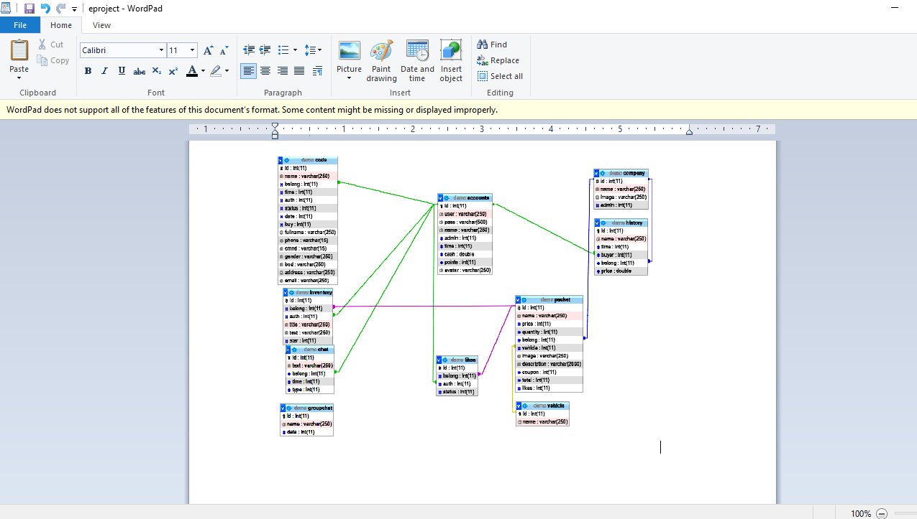

**Website Introduct**

**Part required:**

* **Home**

*Includes logo, separate parts, details of existing insurance packages*

* Insurance

*Insurance package information is sorted by name, when users want to see details of any insurance package, click on that insurance package.*

*When customers click on a brand, a list of brands will be displayed with a brief introduction to individual insurance packages.*

* Contact Us

*This page will show contact information for the company via phone number, email, and company address on google map.*

**Creative part**

In addition to meeting the basic requirements, the website is also somewhat creative through the following specific tasks:

* Language Translation

*Support translating from Vietnamese into English and English to Vietnamese*

* Product reviews

*Allow customers to evaluate the product as well as give suggestions when needed*

* Group chat

*This is a place to support members of the company can exchange jobs with each other conveniently*

**Illustrating images**

* **Home**

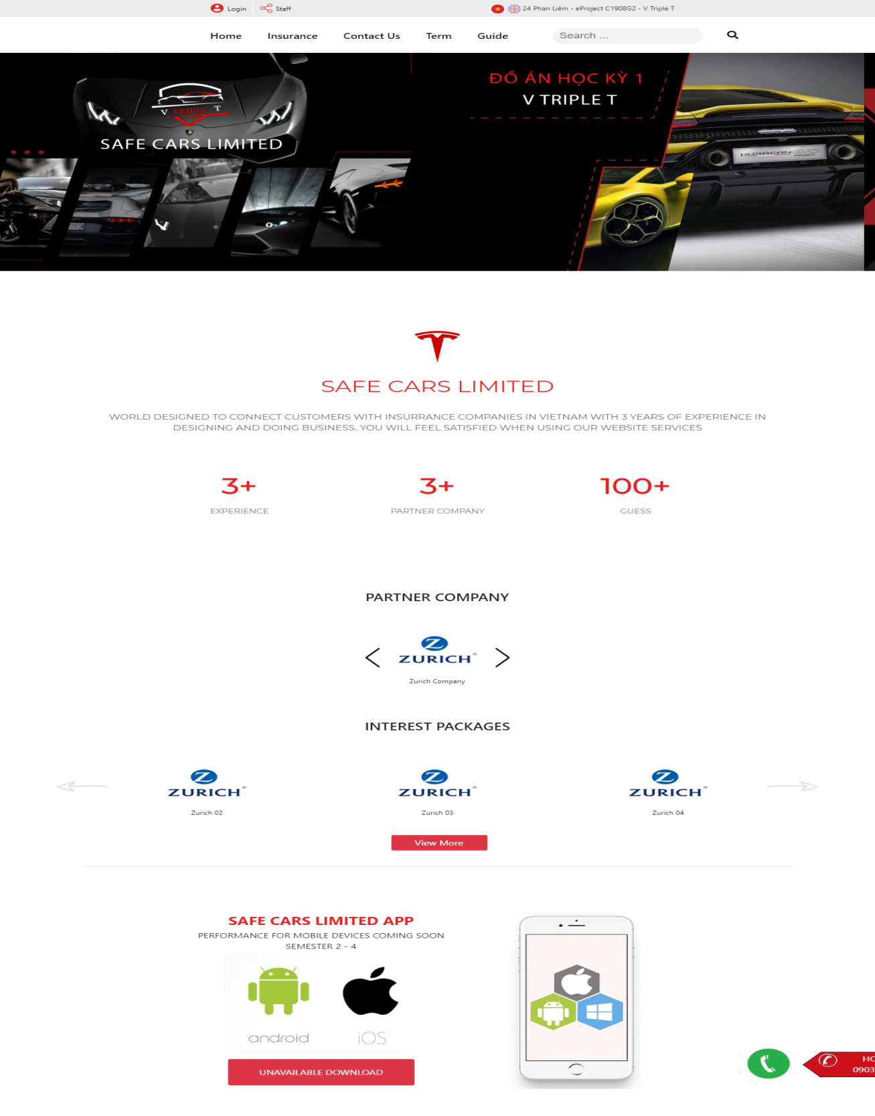

* **Register**

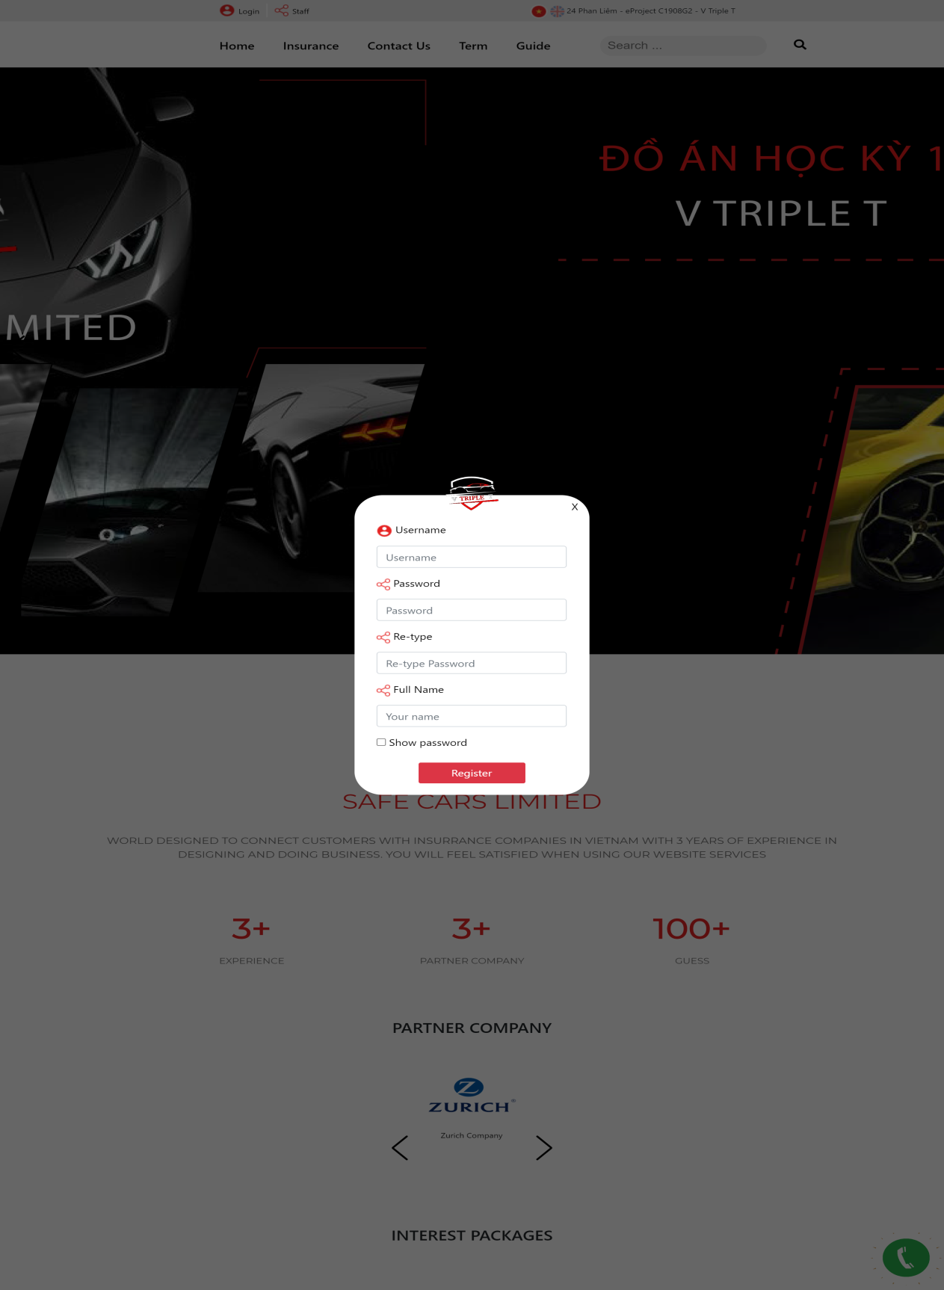

* **Login**

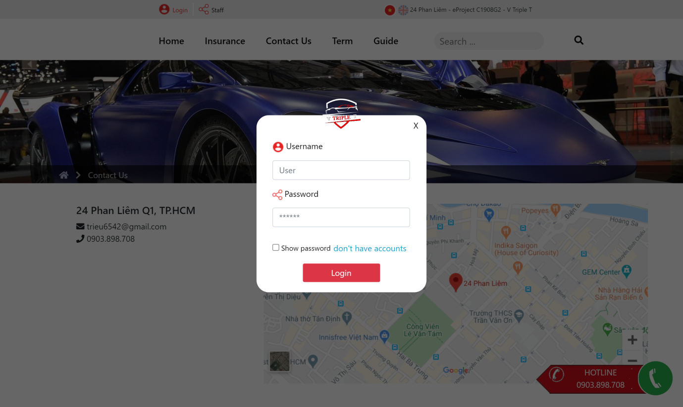

* **Contact Us**

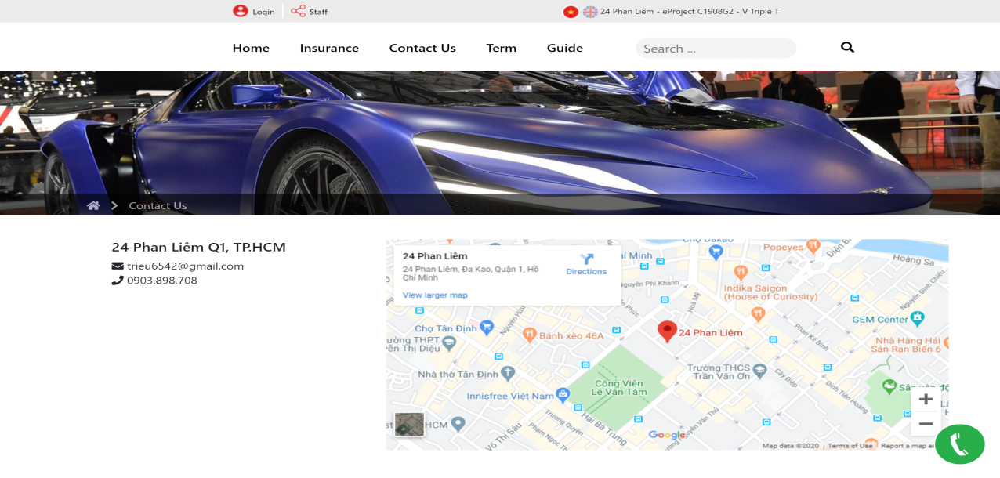

* **Buy insurance package**

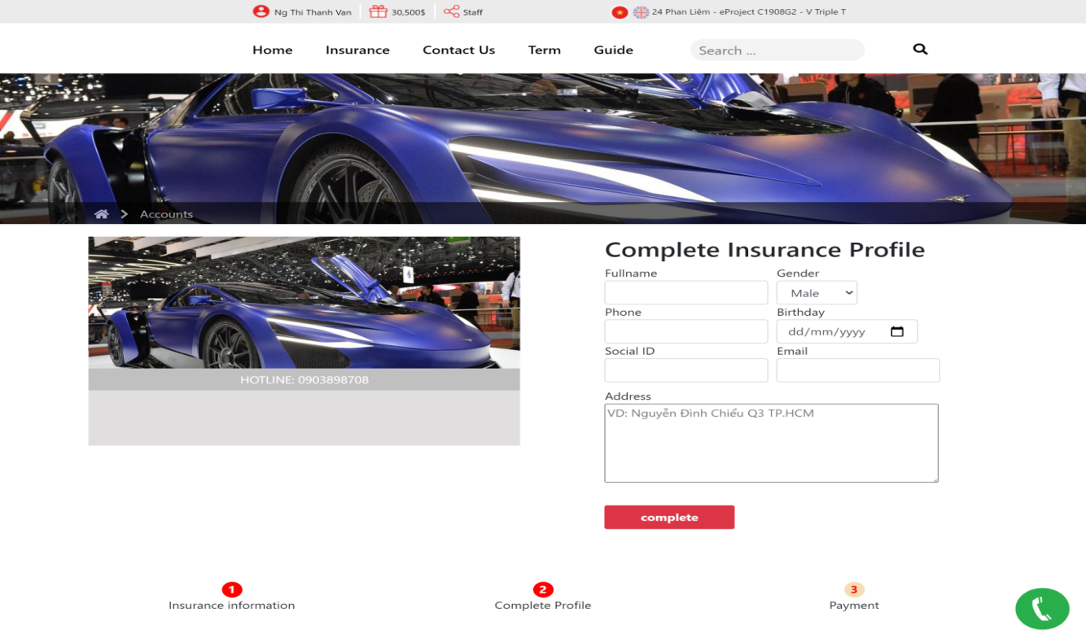

***When you successfully log in to your account, you can do the following:***

* **History**

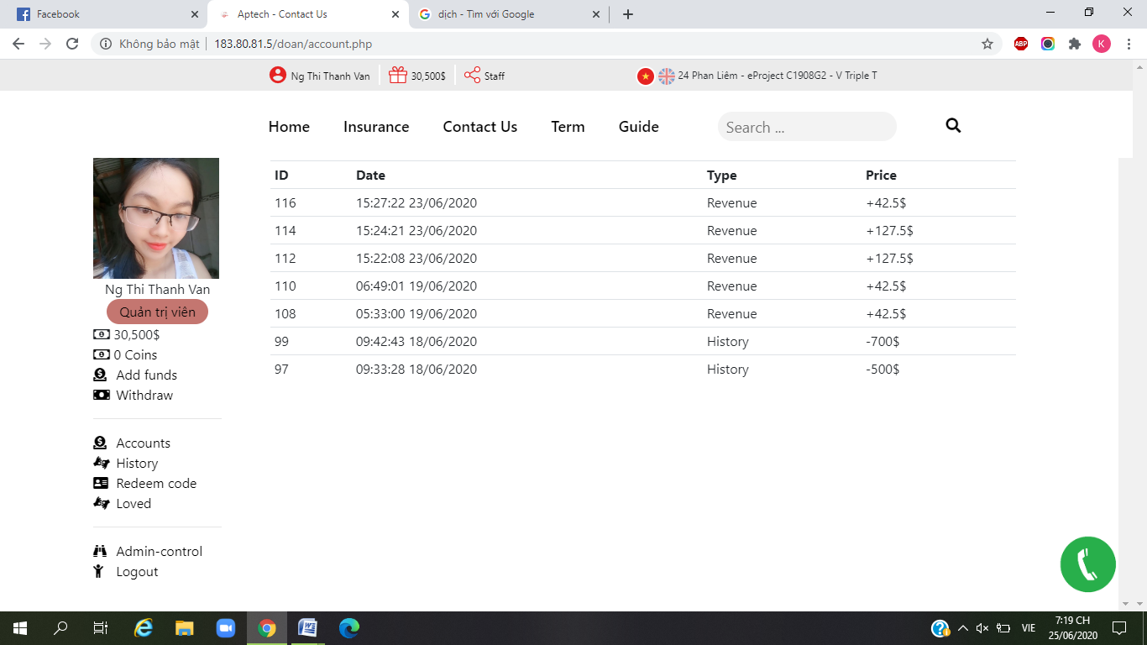

* **Account**

***Used to change password***

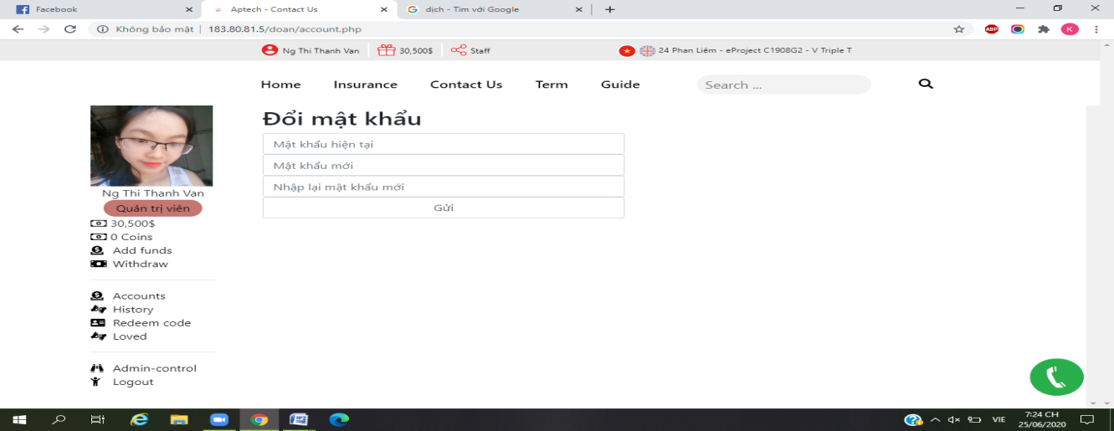

* **Add funds**

***Used to top up the web***

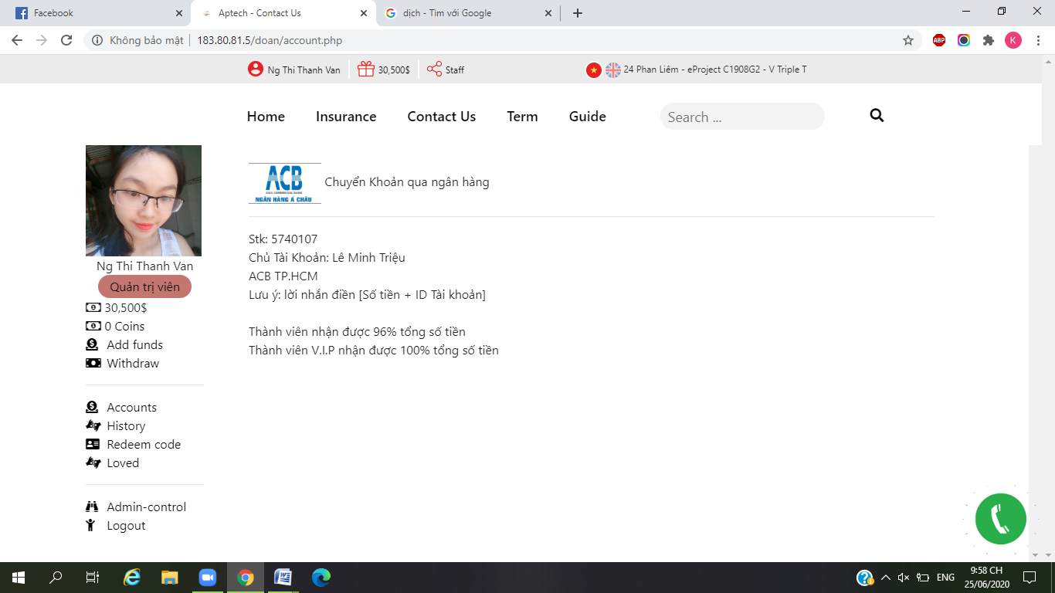

* **Admin-control**

***Allows admin to add - delete - correct company names and insurance packages***

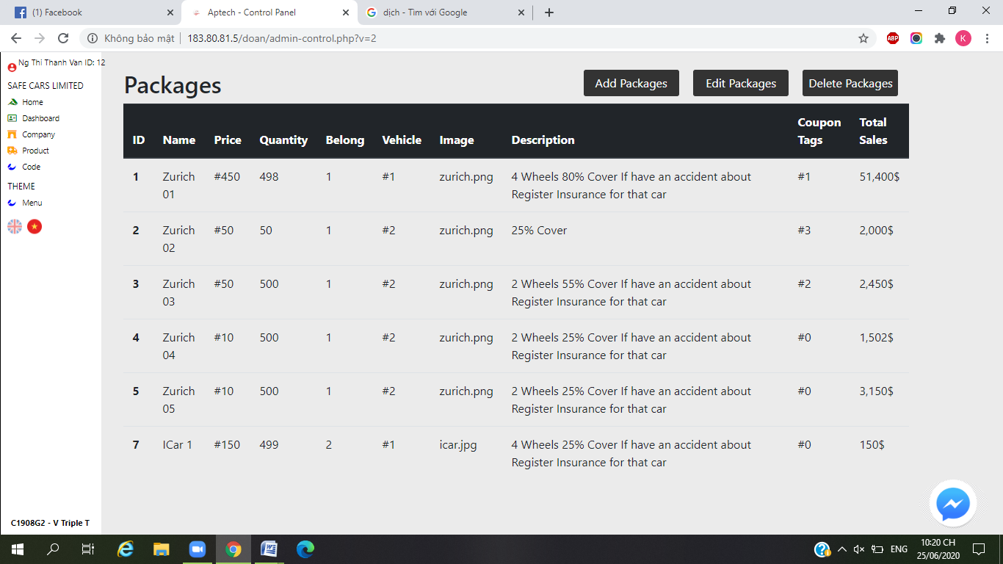

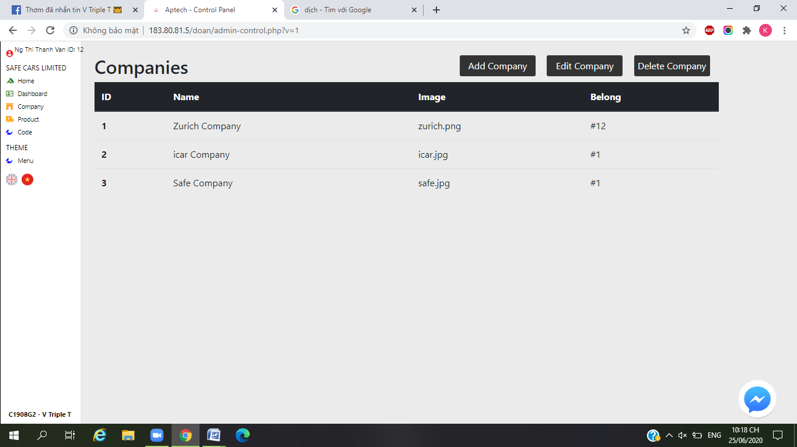

* **Group chat**

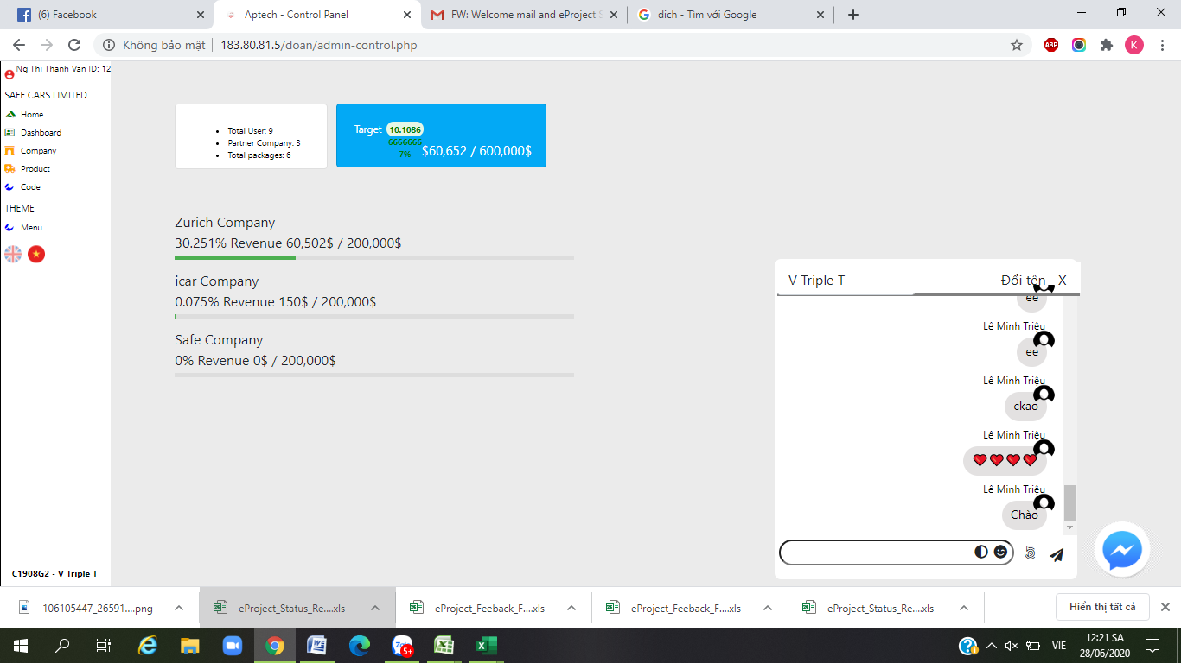

* **Insurance**

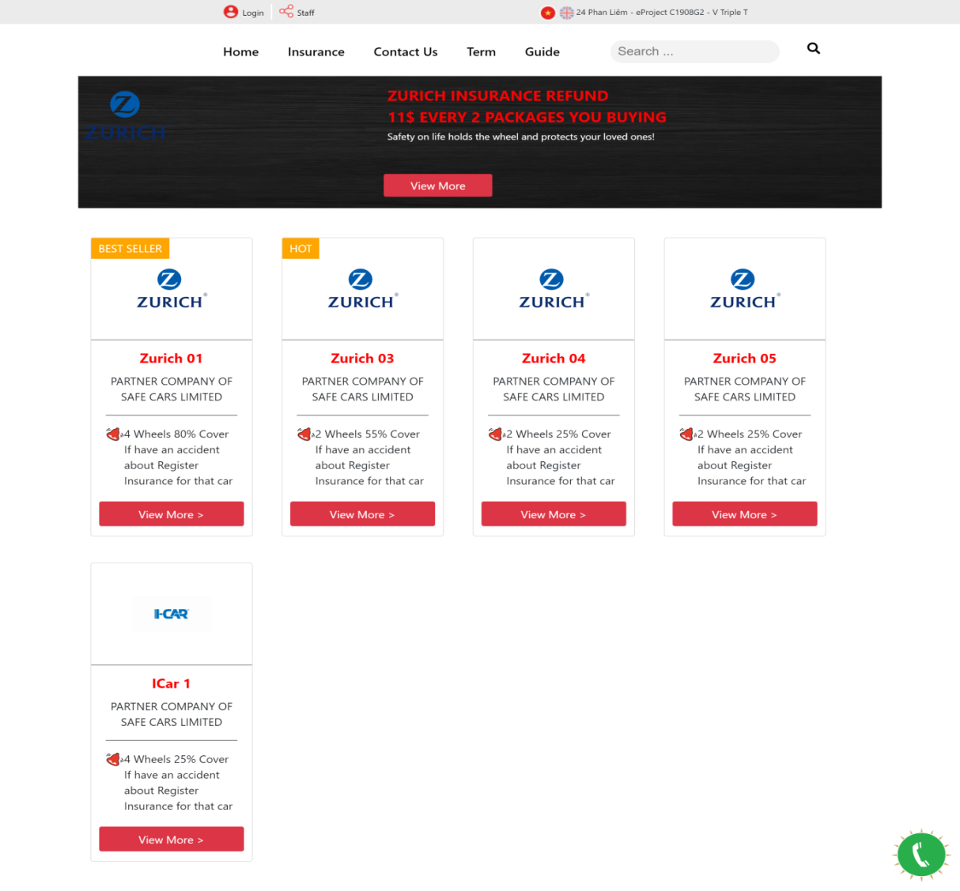

* **Product Reviews**

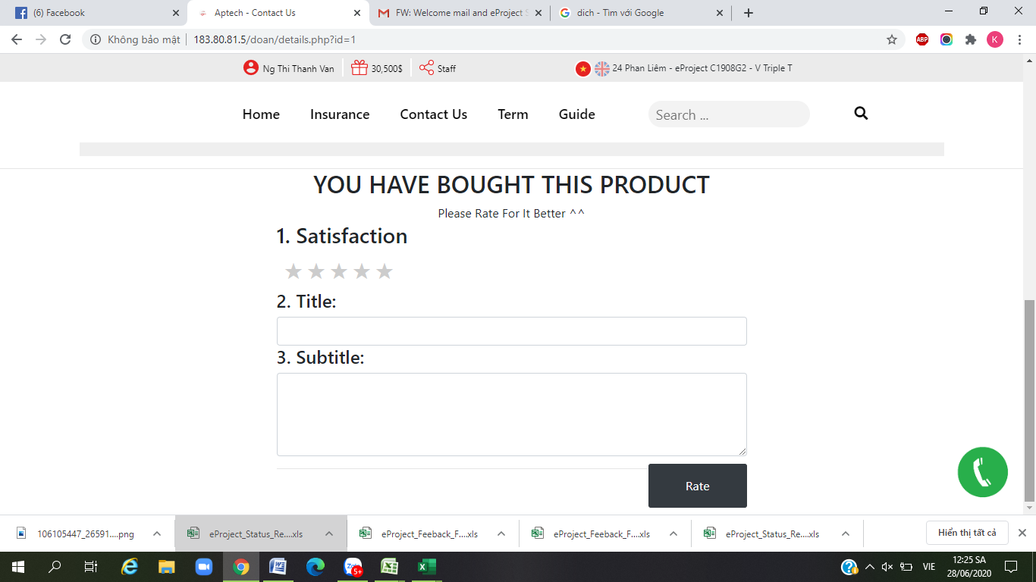

**___________END___________**